

INTERNET OF THINGS

Class: 3rd year EECE department

Mini Project: MODERN LAMP WITH TOUCH SENSOR

**P. Lokini (BU21EECE0100197)**

**U. Pavani (BU21EECE0100474)**

**C. Koushitha (BU21EECE0100403)**

**S. Kashida (BU21EECE0100512)**

**Naga Chaithanya (BU21EECE0100521)**

**Martha Meghana (Bu21EECE0100528)**

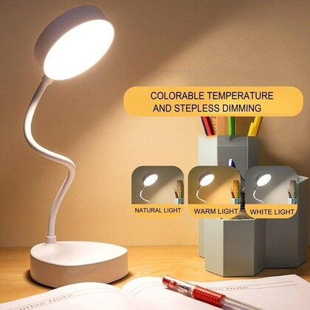

INTRODUCTION:

A touch sensor, also known as a tactile sensor or touch-sensitive sensor, is a type of input device that detects touch or pressure on its surface. These sensors are used in a variety of applications ranging from consumer electronics to industrial machinery. The basic principle behind touch sensors involves the conversion of physical touch or pressure into electrical signals, which can then be interpreted by electronic systems.

Touch sensors are widely used in smartphones, tablets, laptops, and other touchscreen devices, where they enable intuitive interaction with the user interface. They are also employed in industrial automation, robotics, automotive systems, and medical devices for tasks such as object detection, human-machine interface, and gesture recognition. With advancements in technology, touch sensors have become more sophisticated, offering features such as multi-touch support, waterproofing, and enhanced durability.

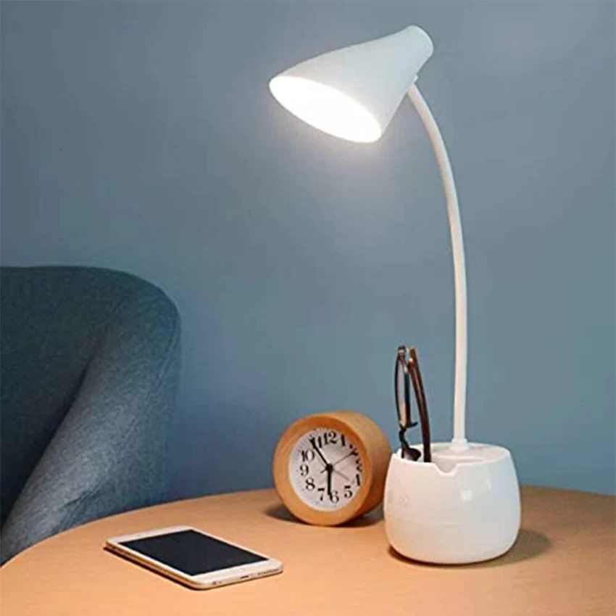

Agenda:

* Components Required
* Block Diagram
* Circuit diagram
* Code
* Procedure
* Conclusion

**Some information:**

* There are different types of touch sensors, including resistive, capacitive, and surface acoustic wave (SAW) sensors, each with its unique working principle and application.
* Resistive touch sensors consist of two flexible layers coated with a resistive material, and when pressure is applied, the layers make contact, causing a change in electrical resistance.
* Capacitive touch sensors detect touch by measuring changes in capacitance caused by the proximity or touch of a conductive object, such as a finger.

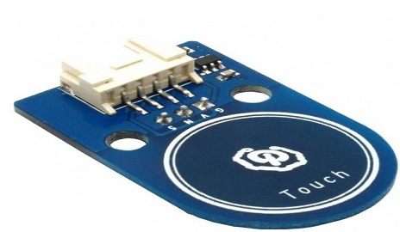

COMPONENTS REQUIRED:

* Arduino UNO
* Touch sensor
* LED bulb
* Jumper wires
* Connecting wire
* And a PC for Coding.

Working principle of Touch sensor:

* A touch sensor operates by detecting physical contact or pressure applied to its surface and converting it into electrical signals that can be interpreted by electronic systems.
* Depending on the type of touch sensor, such as capacitive or resistive, the underlying mechanisms vary.
* Capacitive touch sensors utilize changes in capacitance caused by the proximity or touch of a conductive object, like a finger, to detect touch events.
* This is achieved through a grid of electrodes separated by an insulating material.
* When the conductive object disrupts the electric field between the electrodes, it triggers a change in capacitance that is detected by the sensor.
* On the other hand, resistive touch sensors consist of two conductive layers separated by an insulating layer.
* When pressure is applied to the surface, the top layer makes contact with the bottom layer, creating a circuit and resulting in a change in resistance.
* The sensor detects this resistance change and registers it as a touch event.
* In both cases, the touch sensor relays this information to a controller or microprocessor, which then processes the input and initiates the corresponding action, such as registering a touch input on a touchscreen display or activating a specific function.
* Touch sensors find extensive use in various applications, including consumer electronics, industrial machinery, automotive systems, and medical devices, enabling intuitive interaction and control.

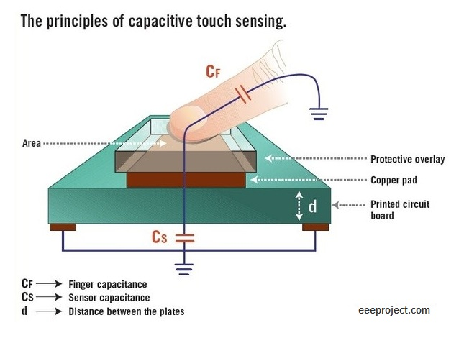

Block Diagram of Touch sensor:

* The block diagram of a touch sensor system with an LED bulb encompasses several interconnected components working together to enable touch detection and LED illumination.
* At the heart of the system lies the touch sensor itself, which detects physical contact and generates an electrical signal indicative of the touch event.
* This signal is then conditioned by signal conditioning circuitry to ensure its accuracy and reliability.
* Following this, the conditioned signal is processed by a microcontroller, serving as the central processing unit of the system.
* The microcontroller interprets the touch signal and triggers appropriate actions based on predetermined instructions. In this case, it controls the LED driver circuitry, which regulates the power supply to the LED bulb.
* The LED driver circuit ensures the LED bulb illuminates according to the touch input, either turning it on, off, or adjusting its brightness.
* The LED bulb serves as the output component, visibly responding to touch events by emitting light.
* Additionally, the entire system is powered by a power supply unit, providing the necessary electrical energy for seamless operation.

This block diagram outlines the functional architecture of a touch-sensitive LED lighting system, illustrating the coordinated interaction between the touch sensor, microcontroller, LED driver, LED bulb, and power supply components.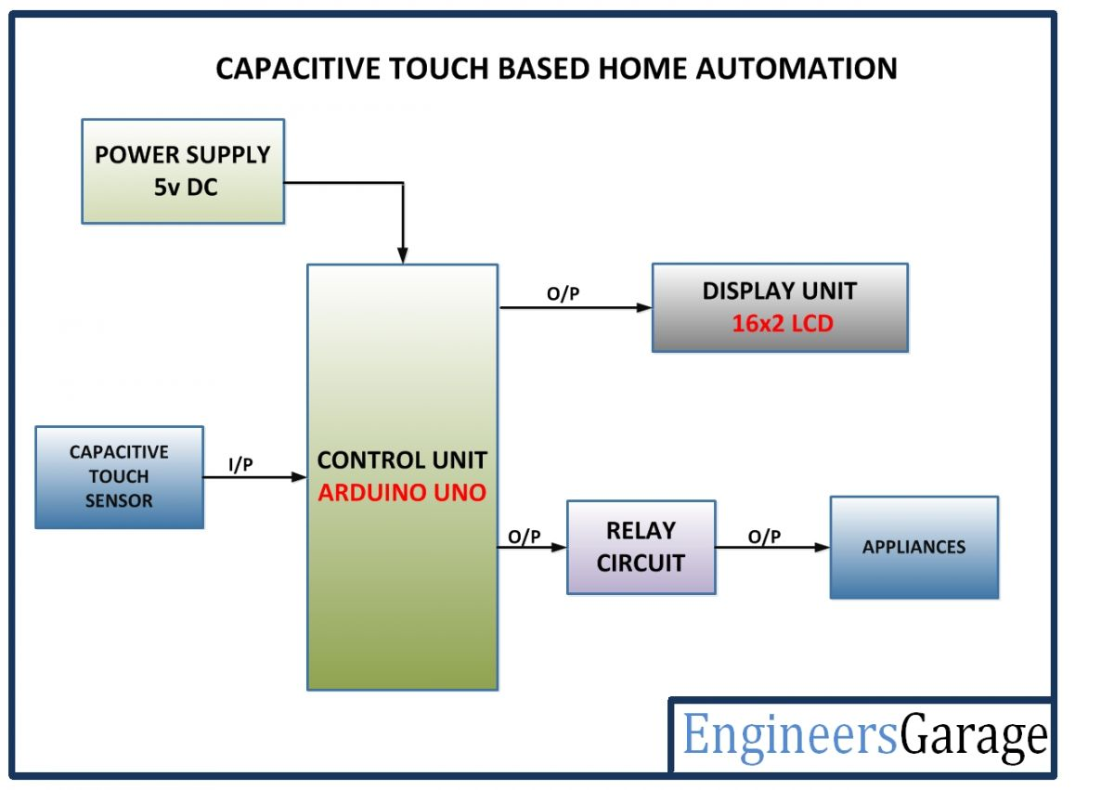

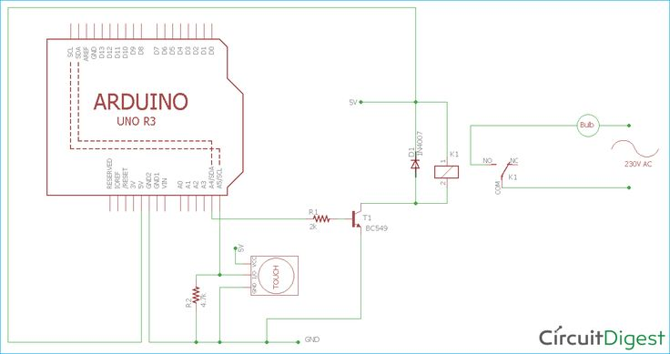

Top of Form

Circuit Diagram of LED light with Touch sensor using Arduino UNO:

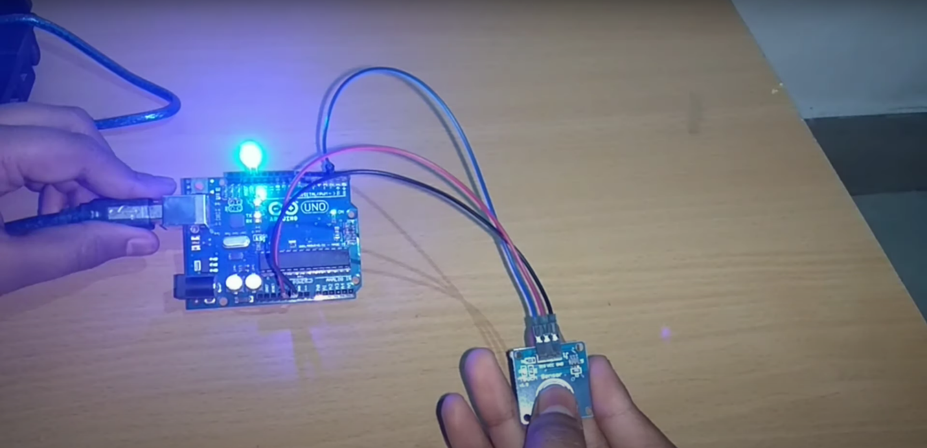

Arduino UNO pin diagram:

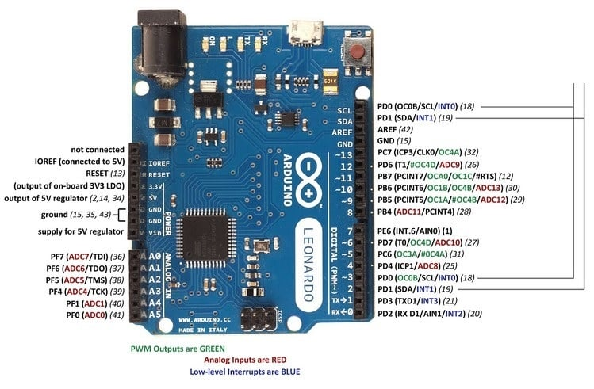

* Arduino is a small computer that you can program to control different things like lights, motors, sensors, and more.
* It's like a tiny brain that you can teach to do all sorts of tasks by writing simple instructions called "code."
* You connect sensors, lights, and other devices to it, and then you tell it what to do in your code.
* It's really popular for making all kinds of gadgets and interactive projects because it's easy to use and great for beginners to learn about electronics and programming.

Touch Sensor Pin Diagram:

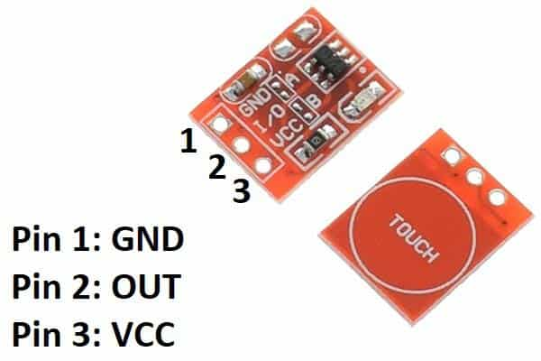

* A touch sensor is a device that can tell when something touches it. Imagine it like a super-sensitive skin that can feel when you touch it.
* When you touch the sensor, it sends a signal to a computer or some other electronic device to let it know that you touched it.
* It's used in lots of things like phones, tablets, and even some kitchen appliances.
* It's a cool way for machines to understand when humans interact with them by touch.

Code for the Touch sensor with LED bulb using Arduino:

#define ctsPin 2

int ledPin = 13;

void setup()

{

Serial.begin(9600);

pinMode(ledPin, OUTPUT);

pinMode(ctsPin, INPUT);

}

void loop()

{

int ctsValue = digitalRead(ctsPin);

if (ctsValue == HIGH)

{

digitalWrite(ledPin, HIGH);

Serial.println("TOUCHED");

}

else

{

digitalWrite(ledPin,LOW);

Serial.println("not touched");

}

delay(0.9);

}

Procedure:

* First place all the components mentioned above in the workspace.
* Next connect all components according to the circuit diagram given above using Jumper wires.
* Connect the gnd pin of the touch sensor to the gnd pin of Arduino, and connect the Vcc pin of the touch sensor to the 5v pins to the Arduino and respectively remaining pin is connected to the 2 (digital) pin.
* Now connect the negative pin of the LED to the GND pin of the Arduino and the positive terminal to the 13 pins of the Arduino.
* Now enter the code and upload it to Arduino IDE.
* Now connect the wire to the Arduino and PC.
* Now touch the sensor to glow the LED light

Conclusion:

In conclusion, integrating a touch sensor with a lamp adds a layer of convenience and interactivity to the lighting system. By simply touching the sensor, users can easily control the lamp's operation, such as turning it on or off, or adjusting its brightness level. This enhances user experience by eliminating the need for physical switches or buttons, offering a more intuitive and streamlined interaction. Additionally, the touch sensor technology contributes to a sleek and modern design aesthetic, making the lamp not only functional but also aesthetically pleasing. Overall, the combination of a touch sensor with a lamp represents a harmonious fusion of technology and design, offering users a convenient and stylish lighting solution for various settings and applications.

